PRIOR AUTHORIZATION METRICS FOR MEDICAL ITEMS AND SERVICES (EXCLUDING DRUGS)

To comply with the CMS Interoperability and Prior Authorization final rule, Network Health is required to annually report aggregated prior authorization metrics on our website.
Specifically, this includes a list of all medical items and services (excluding drugs) that require prior authorization, as well as data on prior authorization requests for those items and services (e.g., approvals, denials, etc.) over the previous calendar year. Publicly reporting these metrics promotes transparency and accountability, helps patients understand prior authorization processes, and enables providers to evaluate payer performance. In addition, metrics can be used to compare plans, programs, and payers. For questions on the data below, contact: 866-709-0019.

Reporting Period: 2025
These are the medical items and services for which we require prior authorization (excluding drugs)

https://networkhealth.com/provider-resources/authorization-information

Prior to January 1, 2026, impacted payers are required to send prior authorization decisions within the following timeframes:

- For MA plans and applicable integrated plans, 72 hours for expedited requests (urgent) and 14 calendar days for standard requests (non-urgent)
- For state CHIP FFS programs, 14 days for standard requests (non-urgent)
- For Medicaid managed care plans and CHIP managed care entities, 72 hours for
expedited requests (urgent) and 14 calendar days for standard requests (non-urgent)
- For QHP issuers on the FFEs, 72 hours for expedited requests (urgent) and 15 days for
standard requests (non-urgent)
There are no Medicaid FFS program required timeframes for either type of prior authorization request prior to January 1, 2026, and there are no CHIP FFS program required decision timeframes for expedited prior authorization requests prior to January 1, 2026.

Beginning January 1, 2026, the CMS Interoperability and Prior Authorization final rule requires Network Health to send prior authorization decisions within:

- 72 hours for expedited requests (urgent)
- 7 calendar days for standard requests (non-urgent)

Standard (non-urgent) Prior Authorization Requests

 | How many times this happened | Out of total requests | Percentage
Request approved | 107,708 | 122,707 | 88%
Request denied | 14,999 | 122,707 | 12%

 | How many times this happened | Out of total requests | Percentage
Request approved only after time for review was extended* | 0 | 0 | 0%

 | How many times this happened | Out of total appeals | Percentage
Request approved only after appeal | 321 | 501 | 64%

Expedited (urgent) Prior Authorization Requests (Response Due to Provider Within 72 Hours)
 | How many times this happened | Out of total requests | Percentage
Request approved | 1938 | 2257 | 86%
Request denied | 319 | 2257 | 14%

 | How many times this happened | Out of total requests | Percentage
Request approved only after time for review was extended* | 0 | 0 | 0%

Time Between Receiving a Prior Authorization Request and Sending a Decision

 | Mean (Average) Time | Median (Middle) Time
Standard (non-urgent) Prior Authorization Requests (response due to provider within 7 calendar days) | 3 days | 2 days
Expedited (urgent) Prior Authorization Requests (response due to provider within 72 hours) | 2 days | 2 days

In 2024, we received a total of 50,000 standard (non-urgent) prior authorization requests for our covered patients.
80% of those requests were approved:
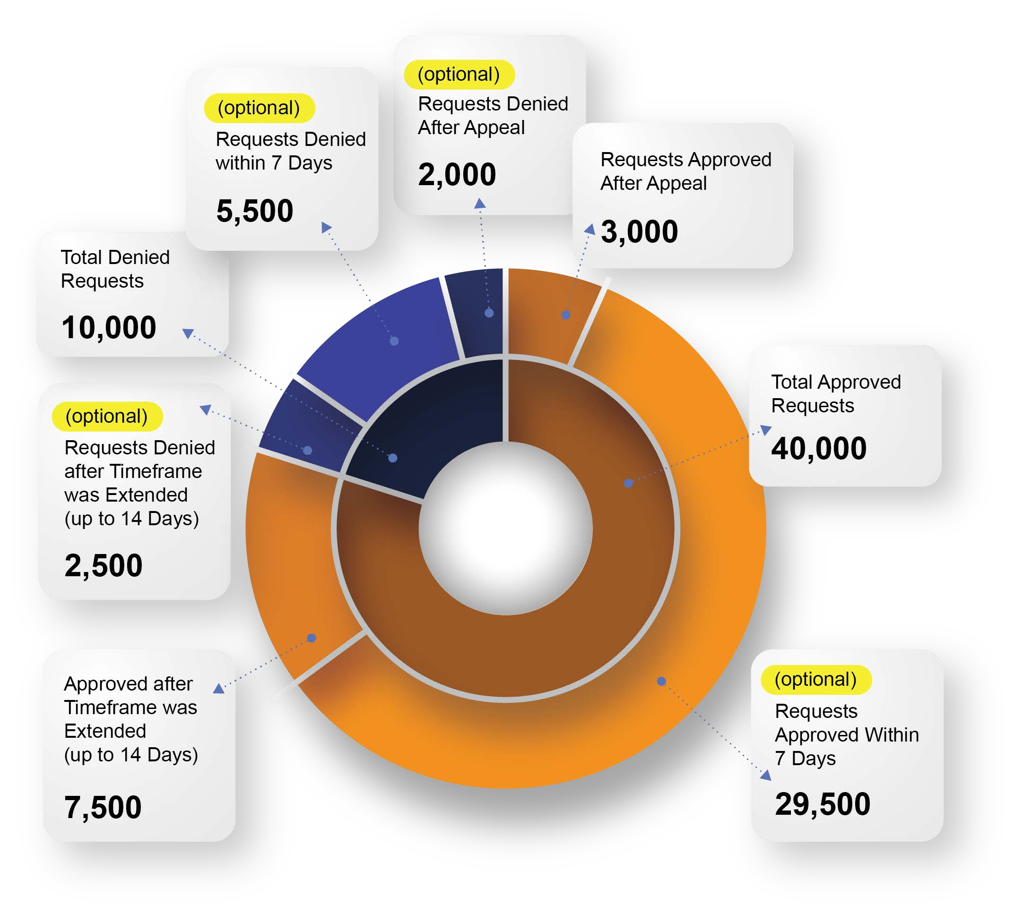

The mean (average) time that it took to make standard prior authorization decisions was | 5 days
The median (middle) time that it took to make standard prior authorization decisions was | 4 days

